Modul Number: 0750362
Module Name: Database Applications

Teacher: Eman Alnaji

Part II
SQL (DDL, DML, SELECT)

SQL: Structured Query Language
- Language for describing database schema and operations on tables
- DDL, DML, DCL and TCL are considered sublanguages of SQL
DDL: Data Definition Language (CREATE, ALTER, DROP)
DML: Data Manipulation Language (INSERT, DELETE, UPDATE)
DCL: Data Control Language (GRANT, REVOKE)
TCL: Transaction Control Language (COMMIT, ROLLBACK)
Tables
- SQL entity that corresponds to a relation
- An element of the database schema
Company Database
In this course we will use the Company database as an example of database to create and manipulate.
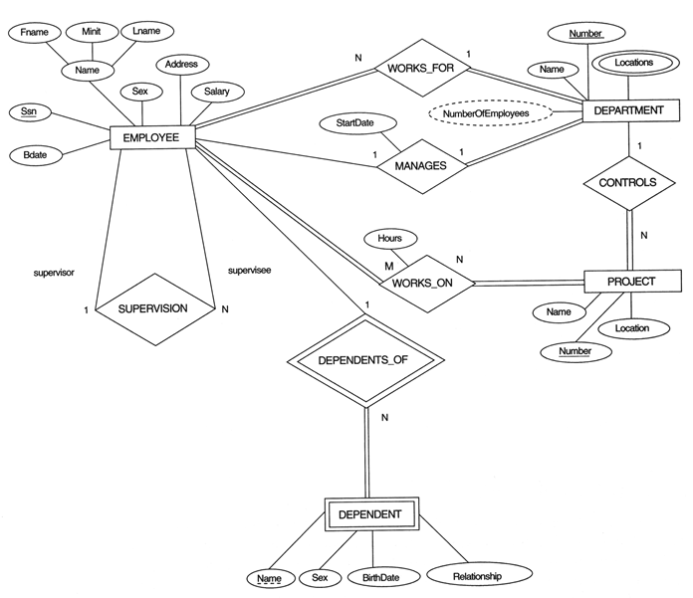
Figure1: Company Database ERD.
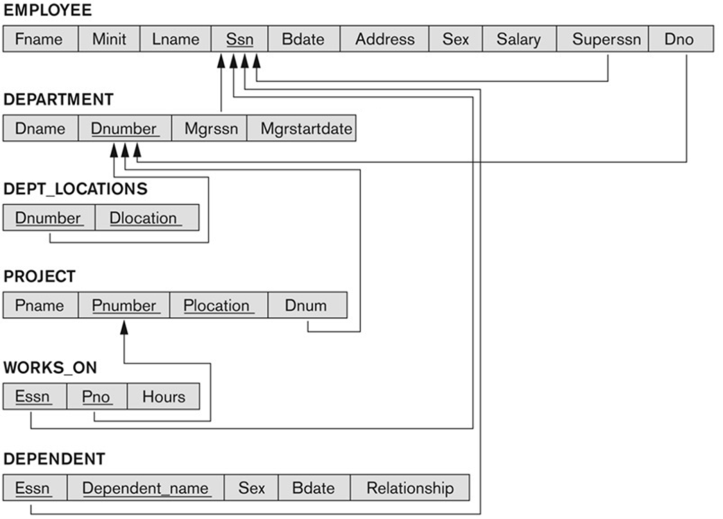
Figure2: Company Database Table Schema
DDL: Data Definition Language
Common SQL Data Types (from Oracle):
String types
CHAR(n) – fixed-length character data, n characters long Maximum length = 2000 bytes
VARCHAR2(n) – variable length character data, maximum 4000 bytes
LONG – variable-length character data, up to 4GB. Maximum 1 per table
Numeric types
NUMBER(p,q) – general purpose numeric data type
Numeric (p, q)- general purpose numeric data type
INTEGER(p) – signed integer, p digits wide
FLOAT(p) – floating point in scientific notation with p binary digits precision
Date/time type
DATE – fixed-length date in dd-mm-yy format
TIME – fixed-length time in hh:mm:ss format

CREATE TABLE
Specifies a new base relation by giving it a name, and specifying each of its attributes with their data types.
A constraint NOT NULL may be specified on an attribute.
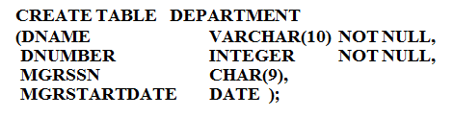
Figure3: The basic CREATE TABLE statement, defining only columns names, data types and NOT NULL constraints.
You can use the CREATE TABLE command for specifying the primary key attributes, candidate keys, and referential integrity constraints (foreign keys).
Key attributes can be specified via the PRIMARY KEY and UNIQUE phrases
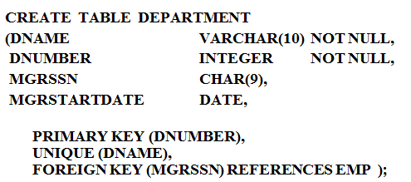
Figure4: CREATE TABLE statement, along with the definition of PRIMARY KEY, UNIQUE key and FOREIGN KEY.
In the previous statement, the definition of a foreign key, will forbid the system from deleting a record from another table that has related records in this table.

But, you can use ON DELETE and ON UPDATE, in the FOREIGN KEY definition, to determine the way of handling the deleting and updating of a record that has related records in this table.
ON DELETE CASCADE when deleting a related record in another table, delete the related records in the current table.
ON DELETE SET NULL when deleting a related record in another table, set the foreign key column to NULL (this can be used if the column is defined as NULL).
ON DELETE SET DEFAULT when deleting a related record in another table, set the foreign key column with the default value determined in the current table. (hint: a default value must be specified in this case).
ON UPDATE CASCADE when changing the primary key in a related table, then change the foreign key related to it, accordingly.
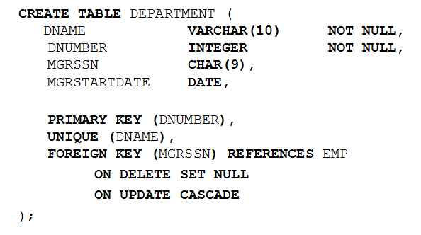
Figure5: Example of ON DELETE and ON UPDATE
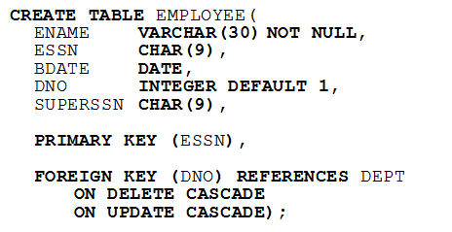
Figure6: Example 2 of ON DELETE and ON UPDATE
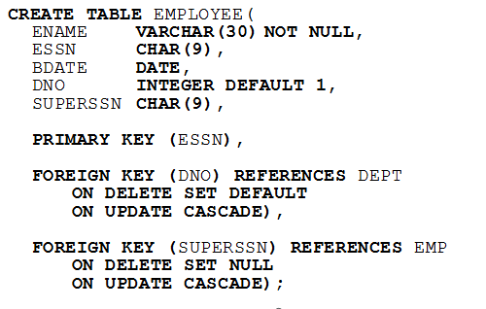
Figure7: Example 3 of ON DELETE and ON UPDATE
Set DEFAULT values for attributes
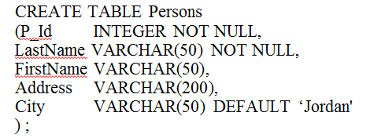
Figure8: Setting default values in table creation

To check the creation of a table, you can view a description of it by using the command DESC.
DESC PERSONS

ALTER TABLE
- Used to add an attribute to one of the base relations
- The new attribute will have NULLs in all the tuples of the relation right after the command is executed; hence, the NOT NULL constraint is not allowed for such an attribute

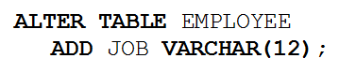
Figure9: Adding a JOB column in table EMPLOYEE
- The database users must still enter a value for the new attribute JOB for each EMPLOYEE tuple. This can be done using the UPDATE command.
- You can change the default value of a certain column, or even set a new default value.
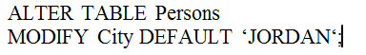
Figure10: Changing the default value of City column
- You can also change the data type or length of an existing column
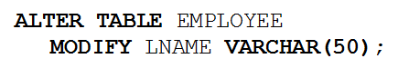
Figure11: Changing the length of column LNAME.
- You can also add a primary key or a foreign key, if you haven’t added them in the create statement.
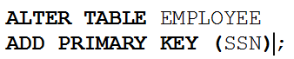
Figure12: Adding a primary key to an existing table
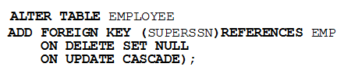
Figure13: Adding a foreign key to table EMPLOYEE

- You can also drop a column that is already existed in a table.
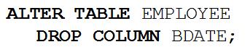
Figure14: Dropping column BDATE from table EMPLOYEE
DROP TABLE
- Used to remove a relation (base table) and its definition
- The relation can no longer be used in queries, updates, or any other commands since its description no longer exists
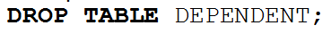
Figure15: Dropping table DEPENDENT
Suppose you need to drop table EMPLOYEE, while it has related records in table DEPENDENT, the system won’t allow dropping it, unless you give order to cancel the constraints between the two tables using the CASCADE keyword.
Figure16: Dropping table EMPLOYEE and dropping all constraints relating this table to other tables.
DML: Data Manipulation Language
There are three SQL commands to modify the database: INSERT, DELETE, and UPDATE.
INSERT
In its simplest form, it is used to add one or more tuples to a relation
Attribute values should be listed in the same order as the attributes were specified in the CREATE TABLE command
Syntax:
INSERT INTO table_name (column,…, column)
VALUES (value, …, value);
- The columns are the names of columns you are putting data into, and the values are that data
- String data must be enclosed in single quotes
- Numbers are not quoted
- You can omit the column names if you supply a value for every column

Example:
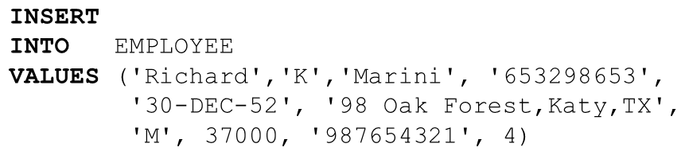
Figure17: Insert Statement
In the previous example, we didn’t specify the names of columns since we are adding values to every column in the table.
The only condition in this case, is to add the values in the order of the columns in the actual table.
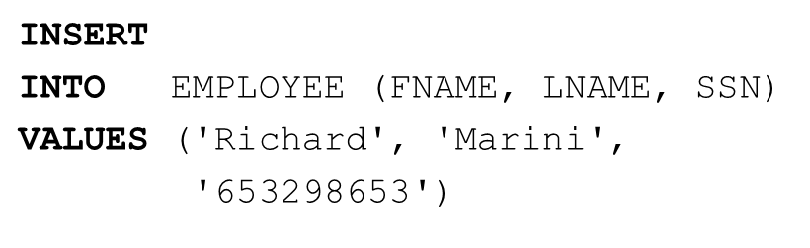
Figure18: Insert Statement
In Figure18, an Insert statement written and some columns are specified. In this case only these columns we have to specify their values. But, we should take into considerations that the other columns in the table can accept NULL values in them, otherwise they should be specified in the Insert Statement.
Important Note: Only the constraints specified in the DDL commands are automatically enforced by the DBMS when updates are applied to the database. i.e. you cannot insert an Employee in a Department that does not exist, because of the Foreign Key constraint between the two tables.
DELETE
- Removes tuples from a relation
- Includes a WHERE-clause to select the tuples to be deleted
- Tuples are deleted from only one table at a time (unless CASCADE is specified on a referential integrity constraint)
- A missing WHERE-clause specifies that all tuples in the relation are to be deleted; the table then becomes an empty table
- The number of tuples deleted depends on the number of tuples in the relation that satisfy the WHERE-clause
- Referential integrity should be enforced
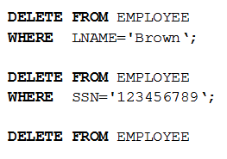
Figure19: Examples on DELETE Statement

UPDATE
- Used to modify attribute values of one or more selected tuples
- A WHERE-clause selects the tuples to be modified
- An additional SET-clause specifies the attributes to be modified and their new values
- Each command modifies tuples in the same relation
- Referential integrity should be enforced
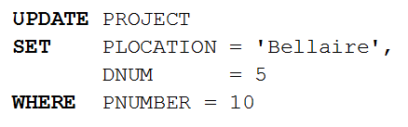
Figure20: Example of UPDATE Statement; updating the location and department number of project of number 10.
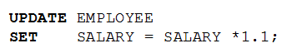
Figure21: Updates the salaries of all Employees by giving them a 10% raise.

Retrieval Queries in SQL
- SQL has one basic statement for retrieving information from a database; the SELECT statement
- Basic form of the SQL SELECT statement is called a mapping or a SELECT-FROM-WHERE block
SELECT <attribute list>
FROM <table list>
WHERE <condition>
  - <attribute list> is a list of attribute names whose values are to be retrieved by the query
  - <table list> is a list of the relation names required to process the query
  - <condition> is a conditional (Boolean) expression that identifies the tuples to be retrieved by the query

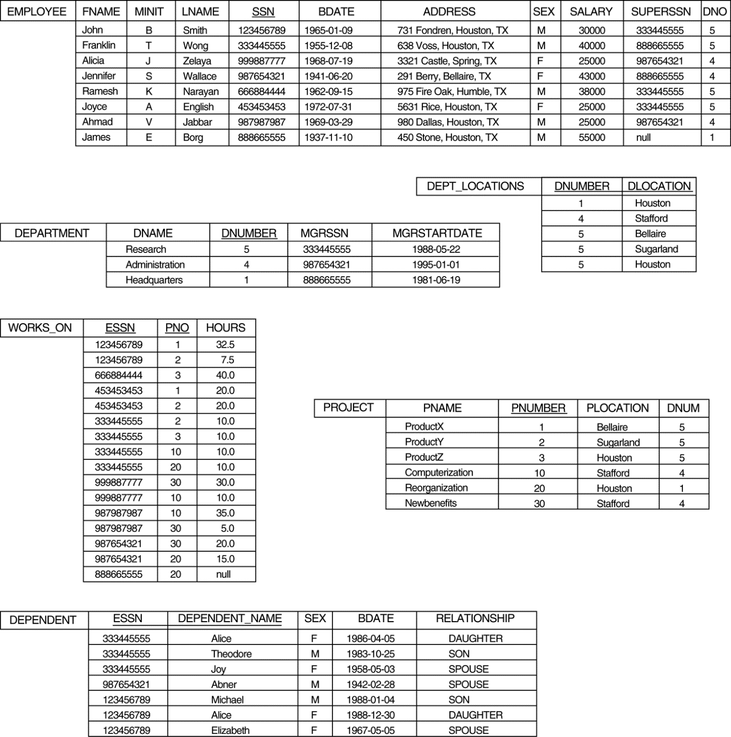
Figure22: The database used in the coming SELECT statements.
In the following pages, SELECT statement will be discussed by examples.
Query0: A simple query on one relation
Retrieve the birthdate and address of the employee whose name is ‘John B. Smith’.
Note here that (birthdate, address and name are all attributes in one relation Employee).
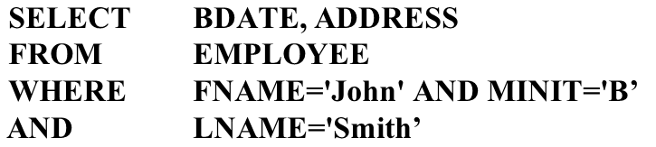
Figure23: Query0
Query1: Retrieve the name and address of all employees who work for the ‘Research’ department.
Note here, that the employee name and address can be accessed from table EMPLOYEE, but the department name does not exist there, we have to use the DEPARTMENT table to find it. So, we need to join both EMPLOYEE and DEPARTMENT tables in the query. (i.e. using the FK).
Figure24: Query1
Note: (DNAME='Research') is a selection condition
(DNUMBER=DNO) is a join condition
Query2: For every project located in 'Stafford', list the project number, the controlling department number, and the department manager's last name, address, and birthdate.
Figure25: Query2
Here we have two Join Conditions:
DNUM=DNUMBER relates a project to its controlling department
MGRSSN=SSN relates the controlling department to the employee who manages that department

ALIASES
In SQL, we can use the same name for two (or more) attributes as long as the attributes are in different relations
A query that refers to two or more attributes with the same name must qualify the attribute name with the relation name by prefixing the relation name to the attribute name
Example:
DEPT_LOCATIONS.DNUMBER, DEPARTMENT.DNUMBER

You can change the name of a table in a query, by giving it an aliases that may be easier to use in a query. Note: That you are not changing the actual name of a table, only giving it another name in the query.
Query3: For every project located in 'Stafford', list the project number, the controlling department number, and the department manager's last name, address, and birth date.
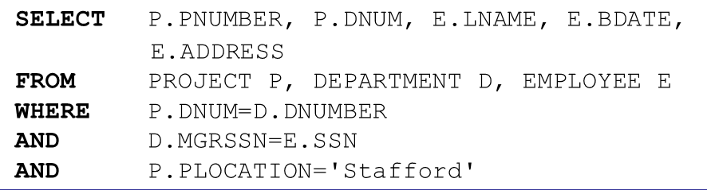
Figure26: Query3
In the previous query, the three tables, PROJECT, DEPARTMENT and EMPLOYEE are given the aliases P, D and E respectively, and they are used to distinguish between the actual tables.

Some queries need to refer to the same relation twice
In this case, aliases are given to the relation name
Query4: For each employee, retrieve the employee's name, and the name of his or her immediate supervisor.
Note here, that in both cases you will need to retrieve the name of an employee, either it was an ordinary employee or a supervisor. In both cases they reside in the table EMPLOYEE. So, we give two aliases to the EMPLOYEE table, and treat it as two copies of the same table.
Figure27: Query4
Unspecified WHERE-Clause
A missing WHERE-clause indicates no condition; hence, all tuples of the relations in the FROM-clause are selected.
Query5: Retrieve the SSN values for all employees.
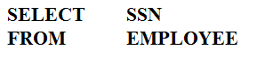
Figure28: Query5
If more than one relation is specified in the FROM-clause and there is no join condition, then the CARTESIAN PRODUCT of tuples is selected.

Query6:
Figure29: Query6

It is extremely important not to overlook specifying any selection and join conditions in the WHERE-clause; otherwise, incorrect and very large relations may result.
USE OF *
To retrieve all the attribute values of the selected tuples, a * is used, which stands for all the attributes.
Query7: Retrieve all attributes of all employees who work in department number 5.
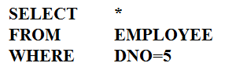
Figure30: Query7
Query8: Retrieve all attributes of all employees along with the attributes of their departments they work for, as long as they work in the ‘Research’ department.
Figure31: Query8

Use of DISTINCT
To eliminate duplicate tuples in a query result, the keyword DISTINCT is used.
Query9: Retrieve the salaries of employees without repetition.
Figure32: Query9

Set Operations
SQL has directly incorporated some set operations
- UNION
- MINUS
- INTERSECT
The resulting relations of these set operations are sets of tuples
- duplicate tuples are eliminated from the result
The set operations apply only to union compatible relations
- The two relations must have the same attributes and the attributes must appear in the same order

Query10: Make a list of all project names for projects that involve an employee whose last name is 'Smith' as a worker or as a manager of the department that controls the project.
- A complete SELECT query, called a nested query , can be specified within the WHERE-clause of another query, called the outer query
- Many of the previous queries can be specified in an alternative form using nesting
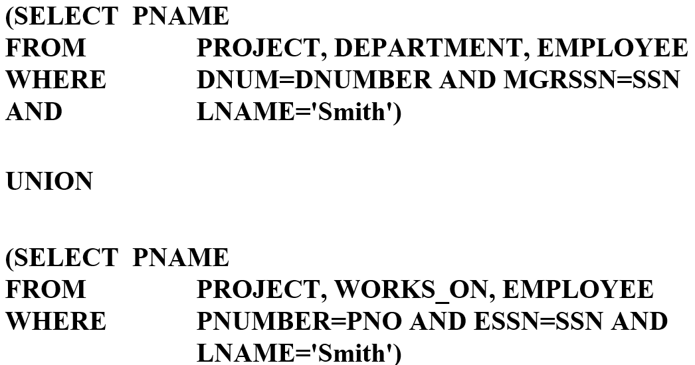
Figure 33: Query10.
Nesting of Queries
A complete SELECT query, called a nested query , can be specified within the WHERE-clause of another query, called the outer query
Many of the previous queries can be specified in an alternative form using nesting
Query11: Retrieve the name and address of all employees who work for the 'Research' department.
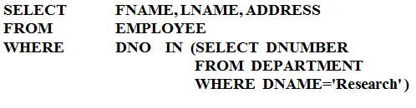
Figure34: Query11
The nested query selects the number of the 'Research' department
The outer query select an EMPLOYEE tuple if its DNO value is in the result of either nested query
The comparison operator IN compares a value v with a set (or multi-set) of values V, and evaluates to TRUE if v is one of the elements in V
In general, we can have several levels of nested queries
In the previous example, the nested query is not correlated with the outer query.
Correlated Nested Queries
If a condition in the WHERE-clause of a nested query references an attribute of a relation declared in the outer query , the two queries are said to be correlated
The result of a correlated nested query is different for each tuple (or combination of tuples) of the relation(s) the outer query
Query12: Retrieve the name of each employee who has a dependent with the same first name as the employee.
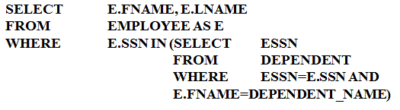
Figure35: Query12
In Query12, the nested query has a different result for each tuple in the outer query.
A query written with nested SELECT... FROM... WHERE... blocks and using the = or IN comparison operators can always be expressed as a single block query.
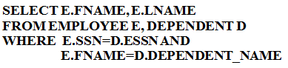
Figure36: Query12 – Rewritten
The EXISTS Function
EXISTS is used to check whether the result of a correlated nested query is empty (contains no tuples) or not
We can formulate Query12 in an alternative form that uses EXISTS as in Query13 below.
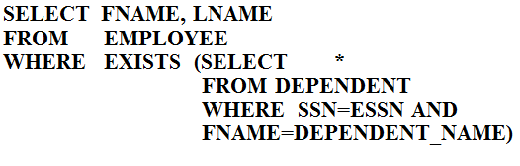
Figure37: Query13.
Query14: Retrieve the names of employees who have no dependents.
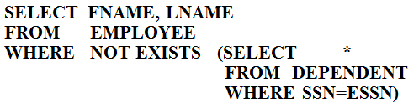
Figure38: Query14
In Query14, the correlated nested query retrieves all DEPENDENT tuples related to an EMPLOYEE tuple. If none exist , the EMPLOYEE tuple is selected.
Explicit SETS
It is also possible to use an explicit (enumerated) set of values in the WHERE-clause rather than a nested query.
Query15: Retrieve the social security numbers of all employees who work on project number 1, 2, or 3.
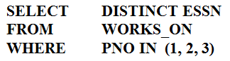
Figure39: Query15.
NULLs in SQL Queries
SQL allows queries that check if a value is NULL (missing or undefined or not applicable)
SQL uses IS or IS NOT to compare NULLs because it considers each NULL value distinct from other NULL values, so equality comparison is not appropriate .
Query16: Retrieve the names of all employees who do not have supervisors.
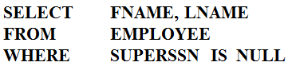
Figure40: Query16
Note: If a join condition is specified, tuples with NULL values for the join attributes are not included in the result.
Query17: Retrieve the names of all employees who have supervisors.
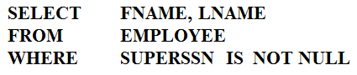
Figure41: Query17
Aggregate Functions
Include COUNT, SUM, MAX, MIN, and AVG.
Query18: Find the maximum salary, the minimum salary, and the average salary among all employees.
Figure42: Query18.
Query19: Find the maximum salary, the minimum salary, and the average salary among employees who work for the 'Research' department.
Figrue43: Query19.
Query20: Retrieve the total number of employees in the company.
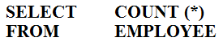
Figure44: Query20
Query21: Retrieve the total number of employees in the 'Research' department.
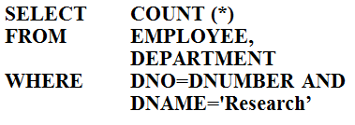
Figure45: Query21
Grouping
In many cases, we want to apply the aggregate functions to subgroups of tuples in a relation
Each subgroup of tuples consists of the set of tuples that have the same value for the grouping attribute(s)
The function is applied to each subgroup independently
SQL has a GROUP BY-clause for specifying the grouping attributes, which must also appear in the SELECT-clause.
Query22: For each department, retrieve the department number, the number of employees in the department, and their average salary.
Figure46: Query22
In Query22, the EMPLOYEE tuples are divided into groups--each group having the same value for the grouping attribute DNO
The COUNT and AVG functions are applied to each such group of tuples separately
The SELECT-clause includes only the grouping attribute and the functions to be applied on each group of tuples
A join condition can be used in conjunction with grouping.
Query23: For each project, retrieve the project number, project name, and the number of employees who work on that project.
Figure47: Query23

In this case, the grouping and functions are applied after the joining of the two relations.
The HAVING-Clause
Sometimes we want to retrieve the values of these functions for only those groups that satisfy certain conditions
The HAVING-clause is used for specifying a selection condition on groups (rather than on individual tuples).
Query24: For each project on which more than two employees work , retrieve the project number, project name, and the number of employees who work on that project.
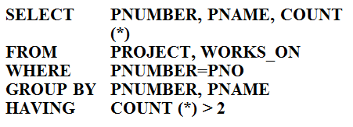
Figure48: Query24
Substring Comparison
The LIKE comparison operator is used to compare partial strings
Two reserved characters are used: '%' (or '*' in some implementations) replaces an arbitrary number of characters, and '_' replaces a single arbitrary character.
Query25: Retrieve all employees whose address is in Houston, Texas. Here, the value of the ADDRESS attribute must contain the substring 'Houston,TX'.
Figure49: Query25
Query26: Retrieve all employees who were born during the 1950s. Here, '5' must be the 8th character of the string (according to our format for date), so the BDATE value is '_______5_', with each underscore as a place holder for a single arbitrary character.
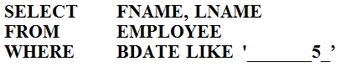
Figure50: Query26
Arithmetic Operations
The standard arithmetic operators '+', '-'. '*', and '/' (for addition, subtraction, multiplication, and division, respectively) can be applied to numeric values in an SQL query result
Query27: Show the effect of giving all employees who work on the 'ProductX' project a 10% raise.
Figure51: Query27

ORDER BY
The ORDER BY clause is used to sort the tuples in a query result based on the values of some attribute(s)
Query28: Retrieve a list of employees and the projects each works in, ordered by the employee's department, and within each department ordered alphabetically by employee last name.
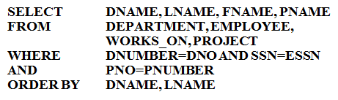
Firgure52: Query28.
The default order is in ascending order of values
We can specify the keyword DESC if we want a descending order; the keyword ASC can be used to explicitly specify ascending order, even though it is the default
Summary of SQL Queries
A query in SQL can consist of up to six clauses, but only the first two, SELECT and FROM, are mandatory. The clauses are specified in the following order:
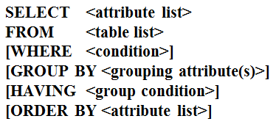
Figure53: Syntax of Select Statement

The SELECT-clause lists the attributes or functions to be retrieved
The FROM-clause specifies all relations (or aliases) needed in the query but not those needed in nested queries
The WHERE-clause specifies the conditions for selection and join of tuples from the relations specified in the FROM-clause
GROUP BY specifies grouping attributes
HAVING specifies a condition for selection of groups
ORDER BY specifies an order for displaying the result of a query
A query is evaluated by first applying the WHERE-clause, then GROUP BY and HAVING, and finally the SELECT-clause
SELECT Statement in DML
Another variation of INSERT allows insertion of multiple tuples resulting from a query into a relation.
Example: Create a temporary table that has the name, number of employees, and total salaries for each department.
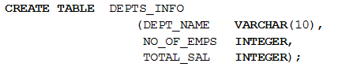
Figure54: Create a new table DEPTS_INFO

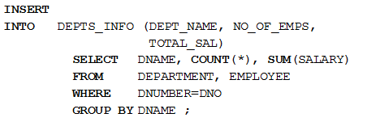
Figure55: Inserting data into DEPTS_INFO using a SELECT Statement
Note: The DEPTS_INFO table may not be up-to-date if we change the tuples in either the DEPARTMENT or the EMPLOYEE relations.
Example2: Delete all Employees in ‘Research’ Department.
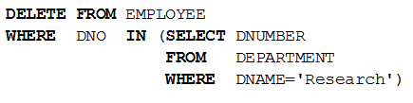
Figure56: Delete from EMPLOYEE table according to a SELECT Statement.

